Lab 9 : Local Connector Testing & Debugging Pipelines

Table of Contents
Table of Contents 2
Introduction 3
Learning Objectives 3
Prerequisites 3
Part 1 — Start a Local Redpanda Broker 4
Isolate Your Local rpk Profile 4
Part 2 — Setup Local Topics 6
Part 3 — Write the Local Pipeline YAML 7
Notice the Differences from Cloud Deployments 7
Part 4 — Run and Debug the Pipeline Locally 8
Step 1 — Run Redpanda Connect Locally 8
Step 2 — Produce Test Data 8
Step 3 — Verify the Transformation 9
Step 4 — Simulate a Bug & Debug 11
Knowledge Check 12
Troubleshooting 12
Symptom: Failed to connect to kafka: dial tcp [::1]:19092: connect: connection refused 12
Symptom: Connect hangs and produces no output when sending data. 12
Next Steps 13
Conclusion 13

Introduction
Deploying untested data pipelines directly into a production Cloud environment is a recipe for broken schemas, poison pills, and costly data cleanup.
The optimal workflow for a Data Engineer is to write the pipeline configuration locally, test it against a local Redpanda broker, debug any transformation errors instantly, and only then promote the pipeline to the Serverless cluster.
In this lab, you will use Redpanda Connect to run a YAML pipeline entirely on your local machine, reading from and writing to a lightweight, locally hosted Redpanda Docker container.

Learning Objectives
Upon completing this lab, you will be able to:
- Quickly spin up a local Redpanda broker for pipeline testing.
- Configure Redpanda Connect to interact with a local localhost broker.
- Test Bloblang transformations locally.
- Identify and debug pipeline errors in an isolated environment.

Prerequisites
- rpk installed on your machine.
- Docker installed and running.
Verify Docker is ready:
docker ps

Part 1 — Start a Local Redpanda Broker
To test our pipeline locally, we need a local broker. We will run a single-node Redpanda cluster using Docker, explicitly configuring it to listen on port 19092 for our local connections.
Run this command in your terminal:
docker run -d --name local-redpanda -p 19092:19092 \
docker.redpanda.com/redpandadata/redpanda:latest \
redpanda start \
--kafka-addr internal://0.0.0.0:9092,external://0.0.0.0:19092 \
--advertise-kafka-addr internal://redpanda:9092,external://localhost:19092

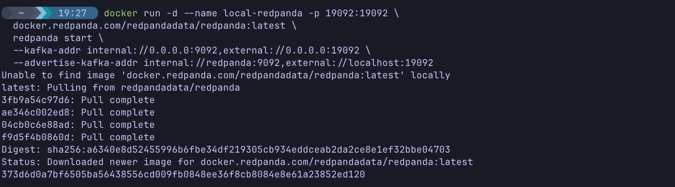

Isolate Your Local rpk Profile
Because you previously connected to a Redpanda Serverless cluster, your rpk CLI is currently holding onto cloud authentication tokens. We need to create a local profile so rpk doesn't try to use cloud credentials against your local Docker container.
# Create and switch to a local profile
rpk profile create local-test

rpk profile set kafka_api.brokers localhost:19092

Verify your local cluster is up and responding
rpk cluster info

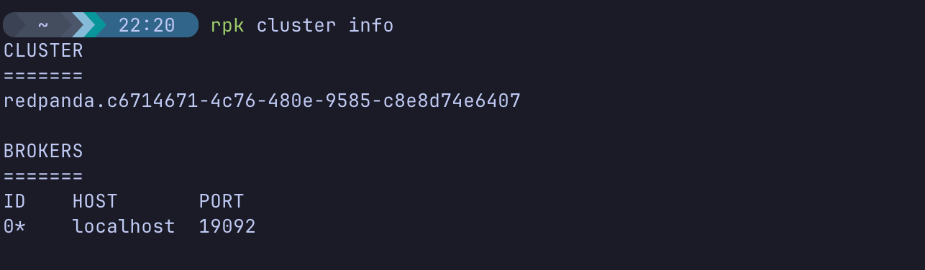
(Notice how you no longer need the -X brokers=localhost:19092 flag!)

Part 2 — Setup Local Topics
Now, let's create the local topics we need for our test pipeline.
Create a new directory for your pipeline development:
mkdir ~/rp-local-connect
cd ~/rp-local-connect


Create a raw input topic and a processed output topic on your local broker:
rpk topic create local-raw -X brokers=localhost:19092
rpk topic create local-enriched -X brokers=localhost:19092

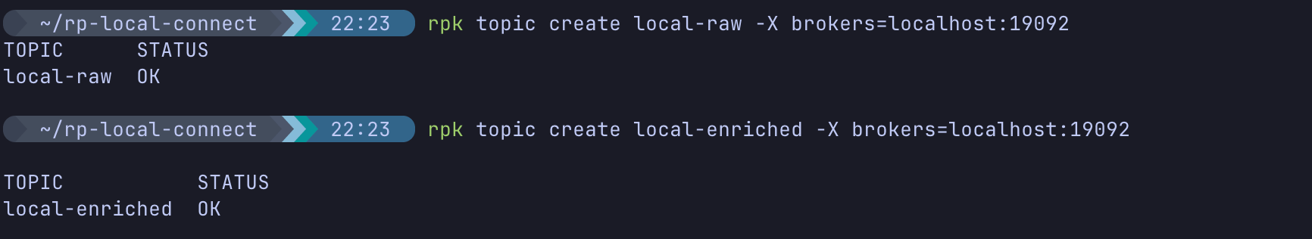

Part 3 — Write the Local Pipeline YAML
We want to build a pipeline that reads from local-raw, applies a Bloblang transformation to uppercase a user's name, and writes to local-enriched.
Create the pipeline file:
nano dev_pipeline.yaml

Paste the following configuration:
input:
kafka:
addresses: [ "localhost:19092" ]
topics: [ "local-raw" ]
consumer_group: "dev-group"
pipeline:
processors:
- bloblang: |
root = this
root.name = this.name.uppercase()
root.processed_at = now()
output:
kafka:
addresses: [ "localhost:19092" ]
topic: "local-enriched"

(Save and exit).

Notice the Differences from Cloud Deployments
- Addresses: We point strictly to localhost:19092 (our local Docker container).
- No Authentication: We removed the tls and sasl blocks completely. Local development is unencrypted and unauthenticated, allowing for rapid iteration without managing credentials.

Part 4 — Run and Debug the Pipeline Locally

Step 1 — Run Redpanda Connect Locally
We will run Connect via Docker. Because we need Connect to talk to localhost:19092 on your host machine, we will use the --network host flag so the container shares your local networking.
docker run --rm -it \
--network host \
-v $(pwd):/data \
redpandadata/connect:latest \
-c /data/dev_pipeline.yaml

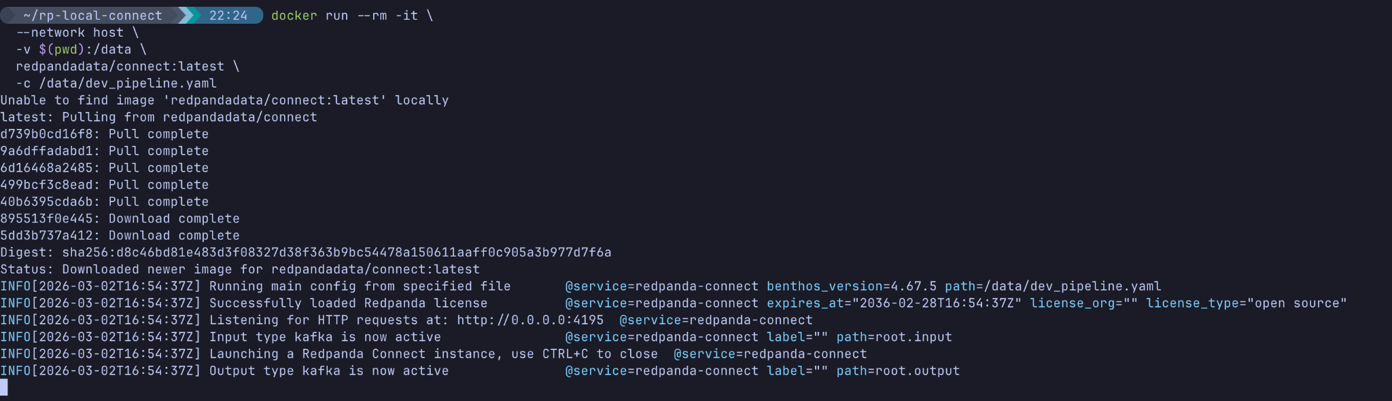
Expected Output: You should see logs indicating it has connected to Kafka and is listening for messages. Keep this terminal open!

Step 2 — Produce Test Data
Open a second terminal window, and inject some test data into the local input topic:
rpk topic produce local-raw -X brokers=localhost:19092

Paste this payload:
{"user_id": 1, "name": "alice wonderland", "action": "click"}

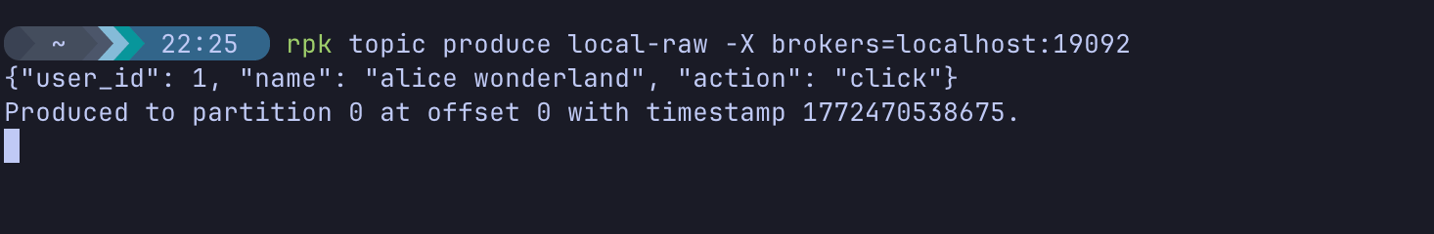
(Press Ctrl+D to exit).

Step 3 — Verify the Transformation
Let's see if our local pipeline successfully transformed the data and wrote it to the output topic.
rpk topic consume local-enriched -o start

Expected Output:
{
"topic": "local-enriched",
"value": "{\"action\":\"click\",\"name\":\"ALICE WONDERLAND\",\"processed_at\":\"2026-03-02T16:55:39.037936846Z\",\"user_id\":1}",
"headers": [
{
"key": "kafka_offset",
"value": "0"
},
{
"key": "kafka_lag",
"value": "0"
},
{
"key": "kafka_timestamp_ms",
"value": "1772470538675"
},
{
"key": "kafka_timestamp_unix",
"value": "1772470538"
},
{
"key": "kafka_tombstone_message",
"value": "false"
},
{
"key": "kafka_key",
"value": ""
},
{
"key": "kafka_partition",
"value": "0"
},
{
"key": "kafka_topic",
"value": "local-raw"
}
],
"timestamp": 1772470539040,
"partition": 0,
"offset": 0
}
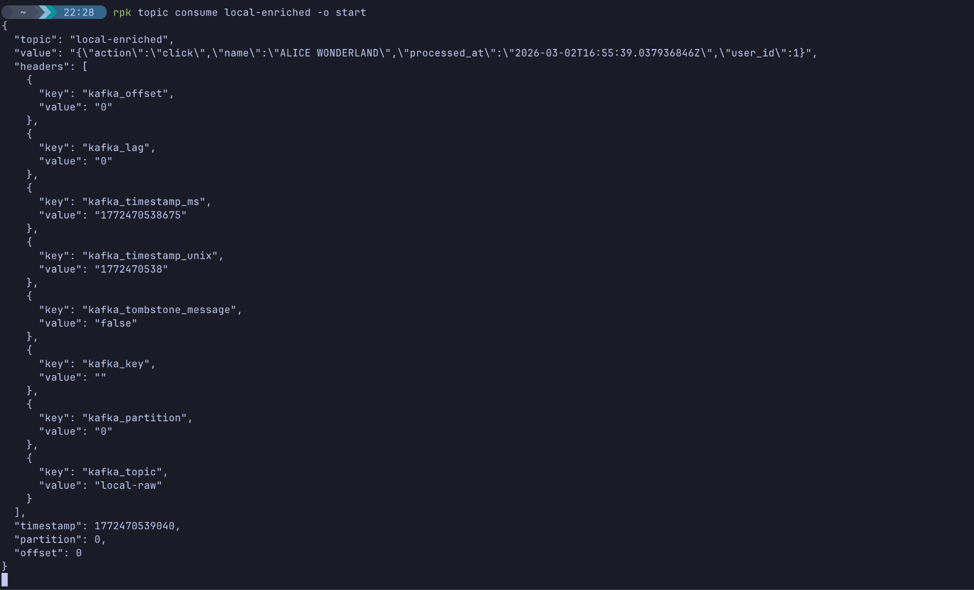
(Press Ctrl+C to exit).
Success! You verified that the .uppercase() Bloblang function works and the processed_at timestamp was added perfectly.

Step 4 — Simulate a Bug & Debug
What happens if bad data hits your pipeline? Let's test it locally where it is safe to fail.
In your second terminal, produce a malformed record (missing the name field entirely):
echo '{"user_id": 2, "action": "login"}' | rpk topic produce local-raw -X brokers=localhost:19092

Look at your first terminal (where Connect is running). You will instantly see an error log:
failed assignment: field `name`: value is null

Because you are developing locally, you caught this bug instantly! To fix it in production, you would update your Bloblang logic to handle missing fields (e.g., using .catch() or Dead Letter Queues), test it locally again, and then push the fixed YAML to the cloud.
(Press Ctrl+C in the first terminal to stop Redpanda Connect).

Knowledge Check
- Why did we use localhost:19092 in our YAML instead of the standard 9092 port?
  - Answer: Because we configured our local Docker container to map port 19092 to the host machine for external traffic. The standard 9092 is typically reserved for internal container-to-container traffic within the Docker network.
- Why is it best practice to test pipelines locally before deploying to Serverless?
  - Answer: It allows you to rapidly iterate on Bloblang logic, catch mapping errors, and validate schemas without risking production data corruption or incurring cloud data transfer costs.
- What does the --network host flag do in the Docker run command?
  - Answer: It attaches the Redpanda Connect container directly to the host machine's network interface, allowing it to resolve localhost exactly as your laptop does.

Troubleshooting

Symptom: Failed to connect to kafka: dial tcp [::1]:19092: connect: connection refused
Solution: Your local Redpanda cluster is not running. Ensure you ran the docker run command in Part 1 to start the local-redpanda container.

Symptom: Connect hangs and produces no output when sending data.
Solution: Ensure you are running the rpk topic produce command against local-raw and the consume command against local-enriched. If you mix up the topics, it will appear as though the pipeline is broken.

Next Steps
Now that you have mastered the local development lifecycle, you can safely tear down your local environment to free up memory on your VM.
Stop and remove the local Redpanda container:
docker stop local-redpanda

docker rm local-redpanda

Conclusion
In this lab, you completed the full local development lifecycle in an isolated environment. You quickly spun up a local Redpanda broker, wrote a Redpanda Connect YAML pipeline, executed it locally, validated your data transformations, and successfully caught a data schema bug. You are now ready to write and safely deploy production-grade pipelines!

